**GREEN VALLEY-FORM DESIGN**

**Form 1:Login**

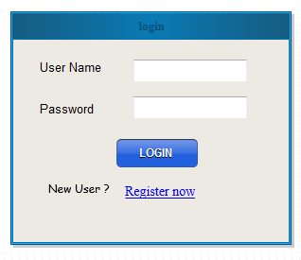

**Form 2: User Registration**

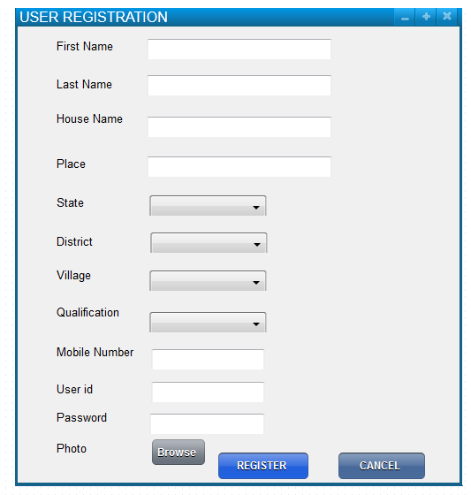

**Form 3:Admin Add/Delete Crops**

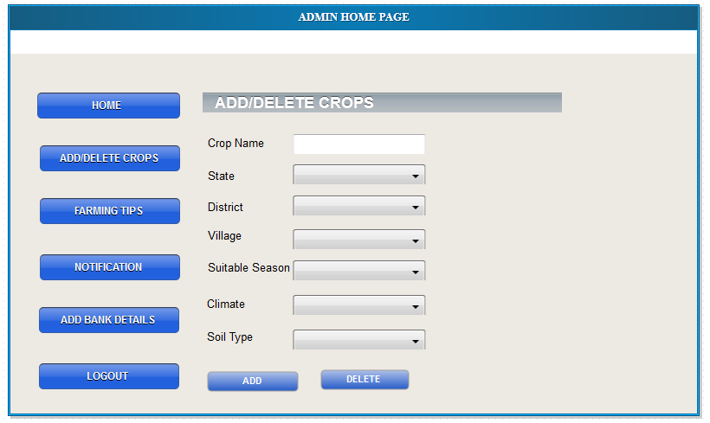

**Form 4: Farming Tips**

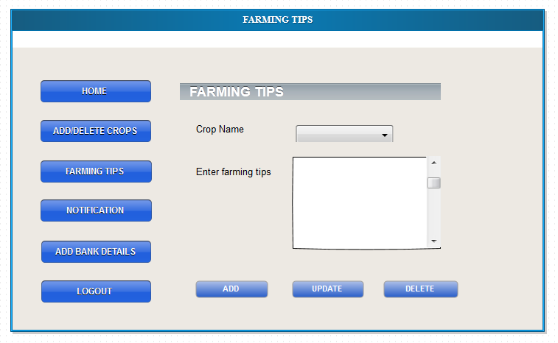

**Form 5: Post Notifications**

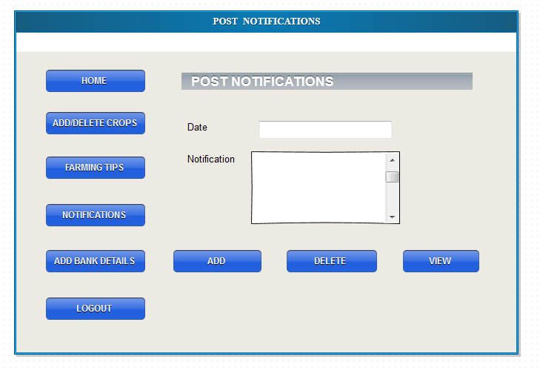

**Form 6:Bank details**

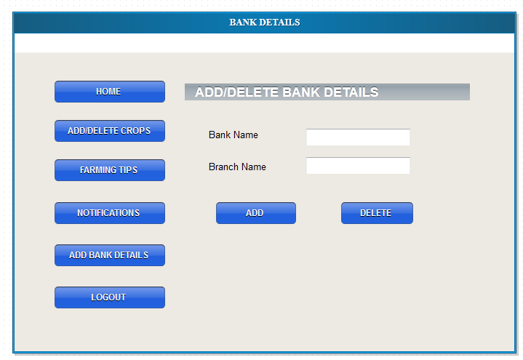

Form 7:User Land Registration

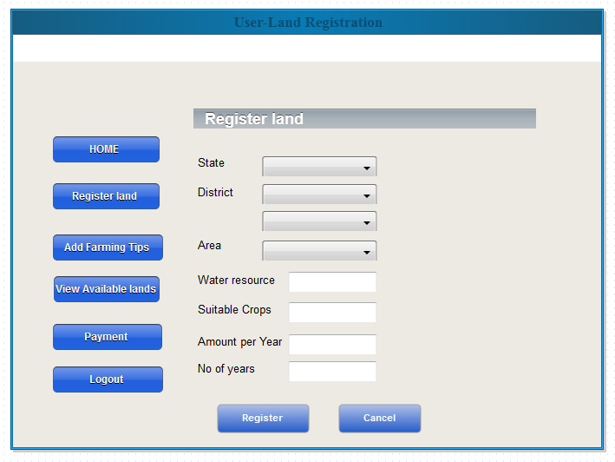

Form 8:User Farming Tips

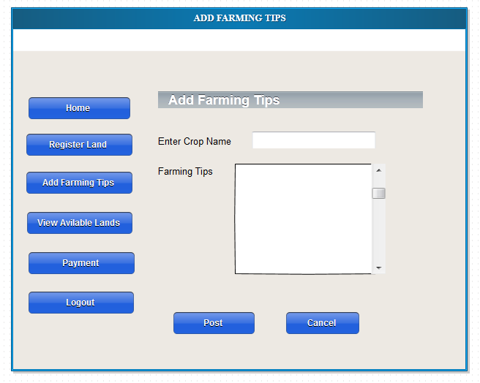

Form 9:View Available Lands

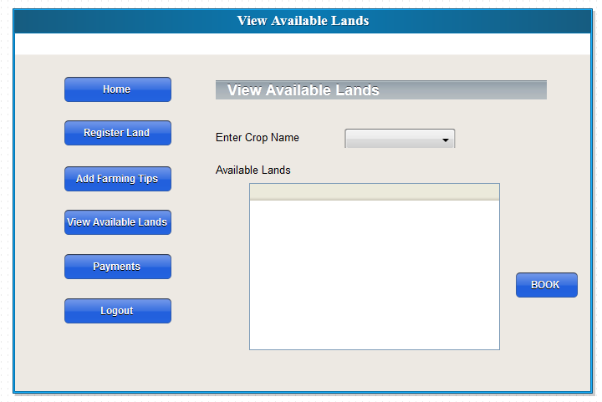

Form 10:User Payment

